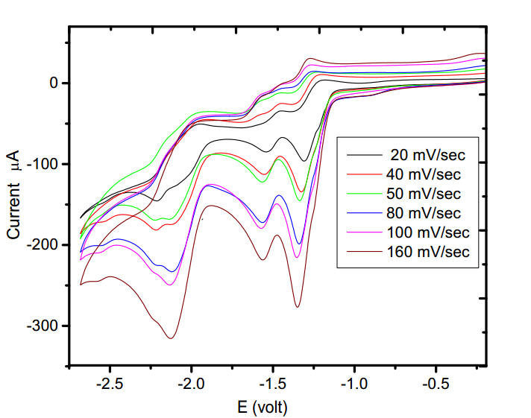

Fig. (1). Cyclic voltammograms of (E)-1-(Furan-2-yl)-3-phenylprop-2-ene-1-one

(10 mM) in tetrabutylammonium tetrafluoro borate.

Solvent = acetonitrile; Working electrode = glossy carbon;

Sweep rate = 20 mV/s, 40 mV/s, 50 mV/s, 80 mV/s, 100 mV/s and 160 mV/s